1.On your Windows laptop or PC, open 'System Information' and take a screenshot showing your OS version, processor, and RAM details.
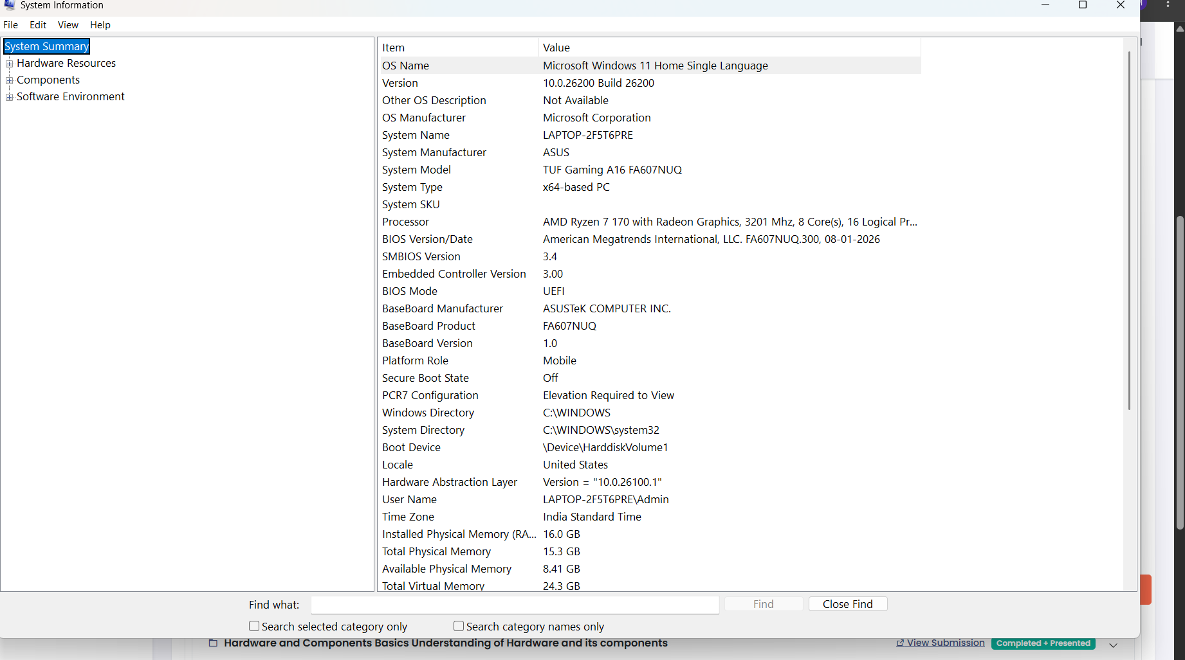
2.Download any official Linux distribution ISO (like Ubuntu or Fedora), and use Rufus or Balena Etcher to create a bootable USB drive for installation. If you don't have a spare USB, use a virtual machine tool like VirtualBox to mount the ISO and start the installation process virtually.
1.Download an official ISO (use only official sources):
- Ubuntu: https://ubuntu.com/download
- Fedora: https://fedoraproject.org/workstation/download
- Debian, Linux Mint, etc.: go to their official sites only.
- Prefer the latest LTS / stable release. Verify the checksum (SHA256) after download if the site provides one.
2.Create the bootable USB:
- Windows: Download Rufus or BalenaEtcher. Select the ISO → select your USB drive → write. (Rufus is usually faster for Linux ISOs.)
- macOS / Linux: BalenaEtcher works cross-platform, or use the built-in dd command carefully.
- Important: This will erase everything on the USB. Use a spare stick (8 GB+ recommended).
3. If you have no spare USB (as the hint suggests):
- Install VirtualBox + the Extension Pack.
- Create a new VM, attach the ISO as a virtual optical drive, allocate enough RAM/CPU/disk, and boot it.
- You can install Linux inside the VM without touching your real hardware.
3.On a macOS device (or using a macOS virtual machine), open 'System Preferences' and change the desktop wallpaper, then adjust the system language to Hindi or Gujarati. Find 'Language & Region' in System Preferences to add or change languages

Task 1: Change the Desktop Wallpaper
Step 1: Open System Settings / System Preferences
- Click the Apple () logo in the top-left corner of the screen.
- Select System Settings (macOS Ventura and later) or System Preferences (macOS Monterey and earlier).
Step 2: Open Wallpaper Settings
- In System Settings, click Wallpaper from the left sidebar.
- In older versions, click Desktop & Screen Saver.
Step 3: Choose a Wallpaper
- Browse through Apple's built-in wallpapers.
- You can also click Photos or Add Folder to use your own picture.
- Select any wallpaper you like.
- The desktop background changes immediately.
Step 4: Verify the Change
- Close the settings window.
- Return to the desktop and confirm that the new wallpaper is visible.

Task 2: Change the System Language to Hindi or Gujarati
Step 1: Open Language Settings
- Open System Settings or System Preferences.
- Select General (if using macOS Ventura or later).
- Click Language & Region.
Step 2: Add a New Language
- Under Preferred Languages, click the + (Plus) button.
- A list of available languages appears.
Step 3: Select Hindi or Gujarati
Choose either:
- Hindi (हिन्दी)
- Gujarati (ગુજરાતી)
Click Add.
Step 4: Make It the Primary Language
- macOS asks whether you want to use the new language as the primary system language.
- Click Use Hindi or Use Gujarati.
- If prompted, enter the administrator password.
Step 5: Restart or Log Out
Some macOS versions require:
- Logging out and back in, or
- Restarting the Mac
to apply the language change throughout the system.
Step 6: Verify the Language
After restarting:
- Open Finder.
- Check that menus, buttons, and system applications are displayed in Hindi or Gujarati.
4. Install a fresh copy of Ubuntu Linux (real or virtual machine) and create a new user account named 'gamer'. After installation, enable automatic login for this user and take a screenshot of the login screen showing the username.4
Step 1: Install Ubuntu
- Download the Ubuntu ISO from the official website.
- Create a bootable USB drive or create a new virtual machine (VirtualBox or VMware).
- Boot from the Ubuntu ISO.
- Select Install Ubuntu.
- Choose your language and keyboard layout.
- Follow the installation wizard.
- When prompted, create your first administrator account (for example, admin).
- Complete the installation and restart the system.

Step 2: Create a User Named "gamer"
- Open Settings.
- Go to System → Users.
- Unlock the settings by clicking Unlock and entering the administrator password.
- Click Add User.
- Select Standard (or Administrator if required).
- Enter:
  - Full Name: Gamer
  - Username: gamer
  - Password: Create a password of your choice.
- Click Add.
Alternatively, using Terminal:
sudo adduser gamer
Follow the prompts to set the password.

Step 3: Enable Automatic Login
- Open Settings.
- Go to System → Users.
- Unlock the page.
- Select the gamer account.
- Turn on Automatic Login.
- Close the Settings window.

Step 4: Restart
Restart the computer:
sudo reboot
The system should automatically log in as gamer without asking for a password.

Step 5: Take the Screenshot
If your instructor specifically wants the login screen showing the username:
- Before enabling automatic login: Log out so the login screen displays the gamer username, then take a screenshot or photo.
- After enabling automatic login: Since the login screen is skipped, many instructors instead accept a screenshot of Settings → Users showing Automatic Login enabled for gamer. If your assignment explicitly requires the login screen, take the screenshot before enabling automatic login.
5.Use ChatGPT to generate a step-by-step guide for installing Windows 10 on a laptop, including partitioning tips and post-installation settings for privacy and updates. Follow the guide and note any steps that were unclear or missing.
1. Prerequisites and Warnings
- You need a working computer (or another machine) to create the installation media.
- A USB flash drive of at least 8 GB (16 GB recommended). Everything on the USB will be erased.
- The target laptop should meet Windows 10 requirements (1 GHz CPU, 2 GB RAM for 32-bit / 4 GB for 64-bit, 32 GB storage, DirectX 9 graphics, etc.). Most laptops from roughly 2015 onward are fine.
- Back up all important data from the target laptop. A clean install will erase the drive if you choose the typical options.
- You need a valid Windows 10 license (digital entitlement linked to the hardware or a product key). Windows 10 is still available via official Microsoft channels for users with existing licenses.
- Prefer a wired Ethernet connection during installation if possible; Wi-Fi drivers sometimes need extra steps.
2. Create Official Windows 10 Installation Media
- On a working Windows PC go to the official Microsoft page: https://www.microsoft.com/software-download/windows10
- Click Download tool now under “Create Windows 10 installation media.”
- Run the Media Creation Tool.
- Accept the license terms.
- Choose Create installation media (USB flash drive, DVD, or ISO file) for another PC.
- Select language, edition (Windows 10), and architecture (64-bit for almost all modern laptops).
- Choose USB flash drive.
- Select your USB drive and click Next. The tool downloads the files and writes them (this can take 30–90 minutes depending on internet speed).
- When finished, safely eject the USB.
(Alternative: download the ISO and use Rufus or the Media Creation Tool’s ISO option, then burn/write it yourself.)
3. Prepare the Laptop and Boot from USB
- Insert the USB into the target laptop.
- Restart the laptop and immediately enter the boot menu (common keys: F12, F10, F9, Esc, F2, Del — varies by manufacturer; watch the screen for the prompt).
- Select the USB drive (often listed as UEFI: [USB brand] or similar). Prefer the UEFI entry if available.
- If the laptop uses Secure Boot and the USB is not signed properly, you may need to temporarily disable Secure Boot in the UEFI/BIOS settings. Re-enable it later if desired.
- The Windows Setup screen should appear.
4. Windows Setup – Initial Screens
- Choose language, time/currency format, and keyboard. Click Next.
- Click Install now.
- Enter your product key if you have one, or click I don’t have a product key (you can activate later with a digital license).
- Select the Windows 10 edition that matches your license (usually Home or Pro).
- Accept the license terms.
- Choose Custom: Install Windows only (advanced). Do not choose Upgrade if you want a clean install.
5. Partitioning Tips (Critical Section)
You now see the drive-selection screen listing disks and partitions.
Recommended clean-install approach (erases the entire drive):
- Select each existing partition on the target disk one by one and click Delete. Confirm each deletion.
- When only “Unallocated Space” remains, select it and click New.
- Windows will automatically create the required partitions (EFI System Partition, MSR, Primary, Recovery). Accept the defaults.
- Select the large Primary partition and click Next.
If you want to dual-boot or keep existing data (advanced):
- Do not delete partitions that contain data you need.
- Shrink an existing Windows partition from within the old Windows (Disk Management) beforehand if possible.
- Create a new Simple Volume in the free space, format it NTFS, and install to that new partition.
- Leave the old EFI/boot partitions alone unless you know exactly what you are doing.
- Never delete a partition labeled “Recovery,” “EFI,” or “System” unless you are intentionally wiping everything.
Additional partitioning advice:
- For most users a single large C: drive is simplest.
- If you want a separate data partition, create it after Windows is installed (Disk Management) rather than during setup.
- SSDs: leave the defaults; Windows handles alignment automatically in modern versions.
- If the drive shows as “MBR” instead of GPT and you are on a UEFI system, you may need to convert it (backup first; use diskpart clean + convert gpt only on empty disks).
Click Next after selecting the correct partition. Installation files are copied, the system reboots several times, and the “Getting ready” / “Working on updates” phases begin. This can take 20–60 minutes. Do not turn off the laptop.
6. Out-of-Box Experience (OOBE) – Initial Setup
- Region and keyboard: confirm or adjust.
- Network: connect to Wi-Fi or Ethernet. You can skip if necessary, but connecting is better for updates.
- Account:
  - Microsoft account is pushed strongly. You can choose “Offline account” / “Limited experience” / “Domain join instead” (wording varies by version) to create a local account.
  - Create a local account with a username and password if you prefer not to use a Microsoft account.
- Privacy settings screen: uncheck almost everything (location, find my device, diagnostic data, advertising ID, speech recognition, etc.). You can change these later; it is easier to start restrictive.
- Continue through any Cortana, OneDrive, or activity-history prompts, declining where possible.
- The desktop eventually appears.
7. Post-Installation: Privacy Hardening
Do these steps immediately after reaching the desktop.
- Windows Update first (but control it):
  - Settings → Update & Security → Windows Update → Check for updates.
  - Install all critical updates and reboot as needed. This can take a long time on a fresh install.
- Privacy settings deep dive (Settings → Privacy):
  - General: turn off advertising ID, let websites access language list, track app launches, etc.
  - Speech: turn off online speech recognition.
  - Inking & typing: turn off.
  - Diagnostics & feedback: set to Basic (or Security on Enterprise). Turn off tailored experiences and diagnostic data viewer if present.
  - Activity history: turn off everything and clear history.
  - Location: turn off for the device; review app permissions.
  - Camera / Microphone / Account info / Contacts / Calendar / etc.: set to “Off” by default and enable only for apps you trust.
  - Background apps: disable ones you do not need.
- Additional privacy measures:
  - Settings → Accounts → Sign-in options: disable dynamic lock, Windows Hello if not wanted, etc.
  - Settings → Search → Permissions & history: turn off SafeSearch, cloud content, history.
  - Disable Cortana / Search highlights if still present (varies by feature updates).
  - Uninstall or disable bloatware via Settings → Apps.
  - Consider a hosts-file blocker or a reputable free tool such as O&O ShutUp10++ (use only from the official site) for deeper telemetry control. Review each toggle carefully.
  - Create a system restore point before major changes.
- Optional but recommended:
  - Install your laptop manufacturer’s driver pack or support assistant for chipset, audio, Wi-Fi, GPU, etc., if Windows Update did not pull everything.
  - Enable BitLocker (Pro edition) or device encryption if available.
  - Set a BIOS/UEFI password and re-enable Secure Boot if you disabled it.
8. Post-Installation: Update Management
- Settings → Update & Security → Windows Update → Advanced options:
  - Turn on “Receive updates for other Microsoft products.”
  - Pause updates if you need temporary control (up to 35 days on newer builds).
  - Active hours: set them so reboots do not interrupt you.
- For more control (Pro/Enterprise): use Group Policy (gpedit.msc) to defer feature updates or quality updates.
- Avoid third-party “update blockers” that break security patches; selective delaying is safer than permanent blocking.
9. Final Checks
- Activate Windows (Settings → Update & Security → Activation).
- Create a second local administrator account as a backup.
- Test sleep, shutdown, Wi-Fi, audio, and trackpad.
- Install a modern browser, antivirus if desired (Windows Defender is solid for most users), and your essential software.
- Take a full disk image backup once everything is configured.

